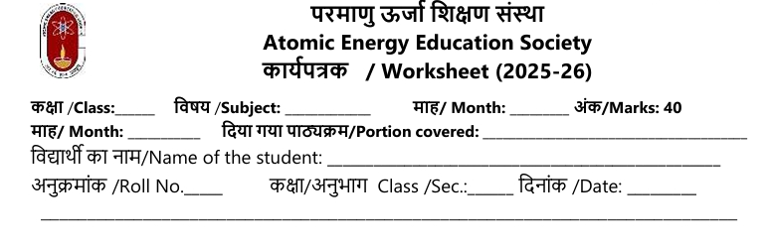Class 7 science
Workheet Chapter 11 Light : shadows and reflection
Multiple Choice Questions ( 1 mark each)
1. Which of these is a luminous object?
(a) Moon (b) Sun (c) Mirror (d) Glass
2. The Moon is classified as:
(a) Luminous (b) Non-luminous (c) Transparent (d) Opaque
3. The main source of natural light for Earth is:
(a) Stars (b) Lightning (c) Sun (d) Fireflies
4. Which is an artificial source of light?
(a) Fire (b) Stars (c) Lightning (d) LED lamp
5. Matchboxes experiment demonstrates:
(a) Light bends around corners (b) Light travels in a straight line (c) Light passes through opaque objects (d) Light forms images
6. When light passes through a transparent material, it:
(a) Is blocked (b) Passes almost completely (c) Passes partially (d) Forms a shadow
7. Tracing paper allows light to pass:
(a) Completely (b) Not at all (c) Partially (d) None of these
8. Which type of material does not allow light to pass?
(a) Transparent (b) Opaque (c) Translucent (d) Clear glass
9. Shadows always form on the:
(a) Opposite side to light source (b) Same side as light source (c) Right side of object (d) Under the object
10. Reflection occurs when light:
(a) Passes through a material (b) Bounces off a shiny surface (c) Forms a shadow (d) Is blocked by opaque material
Assertion Reason Questions (1 mark each)
For each: (a) Both A and R are true, R is correct explanation; (b) Both A and R are true, R is not the correct explanation; (c) A true, R false; (d) A false, R true
11. Assertion (A): The Moon is visible at night because it emits its own light.
Reason (R): The Moon reflects sunlight falling on it.
12. Assertion (A): Shadows are formed when light is blocked by opaque objects.
Reason (R): Transparent objects cause clear shadows.
13. Assertion (A): A plane mirror forms erect, laterally inverted images.
Reason (R): Shadows formed in front of mirrors are always blurred.
14. Assertion (A): Light travels in a straight line.
Reason (R): Bent pipes can make candle flames visible.
Case Based Questions (4 mark)
Read the passage and answer the questions:Passage:
During an activity, students arrange three matchboxes in a straight line and make a hole in each. They observe a candle flame through the holes.
15. What concept does this activity help demonstrate?
(a) Light bends around corners (b) Light travels in a straight line (c) Opaque objects are transparent (d) Candle creates shadows
16. Why is the candle flame not visible through a bent pipe?
(a) Pipe is opaque (b) Light travels in a straight line (c) Pipe is too short (d) Candle too dim
17. If a sheet of tracing paper is put between the candle and your eyes, what do you observe?
(a) No light passes (b) Image is sharp and clear (c) Image is faint (d) Image is inverted
18. Which of the following forms clear shadows?
(a) Transparent object (b) Opaque object (c) Mirror (d) Lens
Short answer type Questions : ( 2 mark )
19. Define “luminous object” and give two examples.
20. What are the conditions to get a shadow?
21. State one difference between a shadow and a reflection.
22. Why does a pinhole camera form an inverted image?23. Explain the role of transparent objects in passing light.
Long answer type Questions : ( 3 mark)
24. Describe how shadows change during the day and why.
25. Write a note on the lateral inversion produced by mirrors.
26. How do shadows help us infer about the shape of objects?
27. Explain, with examples, the real-life uses of reflection.

